Testing the DC Supply Board

Servicing a SuperDARN Transceiver  
Step 3

Content

1. Introduction 3

2. Instructions 3

3. Conclusion 4

# Introduction

This document provides work instructions for testing the DC Supply Board in a SuperDARN transceiver box. Before attempting to implement these instructions, be sure to complete all the preceding steps in the procedure for Servicing a SuperDARN Transceiver.

# Instructions

Following are the step-by-step instructions for testing the DC Supply Board. In the case of unforeseen problems occurring, apply electronic fault-finding techniques.

1. Connect **J1** on the DC Supply Board (50 V). Make sure **J2** and **J3** are also connected to the switch on the front plate and that the switch is in the **OFF** position.
2. Leave all other connections for now – **J4** disconnected from the Power Distribution Board.
3. Switch the mains power on.
4. Confirm that LED **D2** is **ON**, while **D5**, **D6**, **D11** and **D12** are all **OFF**.
5. Now toggle the switch on the front plate to the **ON** position and check that **D10** goes **ON**. If it does not light up, disconnect **J2**. If **D10** then lights up, there is a problem with the switch. Otherwise, check that there is nothing connected to the DC Supply Board that could be pulling current; there may be a short circuit causing the module to shut down. **D10** is the 15 V supply rail.
6. If the steps above do not solve the problem, there is most likely a problem on the board itself and further fault finding will be required.
7. Check that **D2** is **OFF**. If it’s not, it might be an indication that the relay has failed and should be replaced.
8. About 1 second (or sooner) after **D10** lights up, **D11** or **D12** will light up.
   1. **D12** **ON** indicates that the output voltage is good.
   2. **D11** **ON** indicates that there is a fault (over-voltage, under-voltage or over-current).
9. Finally, check the output voltage on the 15 V line of **J4**. It should be about 15 V at no load.
10. Disconnect the white wire (50_en) from the Phoenix connector at **J6** on the Power Distribution Board. Use the desktop power supply to apply exactly 3.3 V to this wire. This will toggle the relay and light up **D2**. If this does not work, there is likely a problem with the relay, and it should be replaced. Verify by measuring the voltage on the 50 V line of **J4** on the DC Supply Board. Replace 50_en back into **J6**.
11. Switch off the 15 V on the front plate and then the mains.

**NOTE**:  
The 50 V relay has been moved off the board due to overheating problems, the leads (in red) go to the where the switch is now mounted directly onto the aluminium chassis with thermal paste. The DC-DC converter is on the back of the board mounted with a screw and thermal paste.

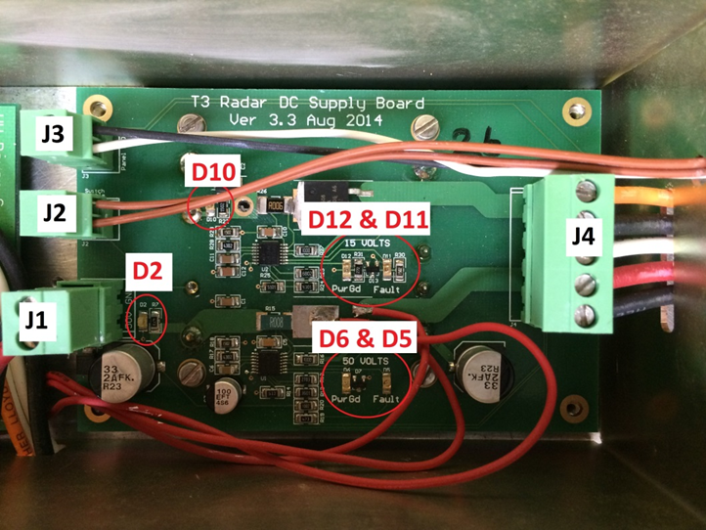

Figure 1. Important components and connections on the DC Supply Board.

# Conclusion

This concludes the work instructions for testing the DC Supply Board of a SuperDARN transceiver box. The next step in the procedure for Servicing a SuperDARN Transceiver is to test the Power Distribution Board.